# Define the terms: Website, Webpage, Web browser, Web server, HTML, CSS

# web page

# A document which can be displayed in a web browser such as Firefox, Google Chrome, Opera, Microsoft Edge, or Apple Safari. These are also often called just "pages."

# website

# A collection of web pages which are grouped together and usually connected together in various ways. Often called a "website" or a "site."

# web server

# A computer that hosts a website on the Internet.

# Create a webpage to show “This is my first HTML page”

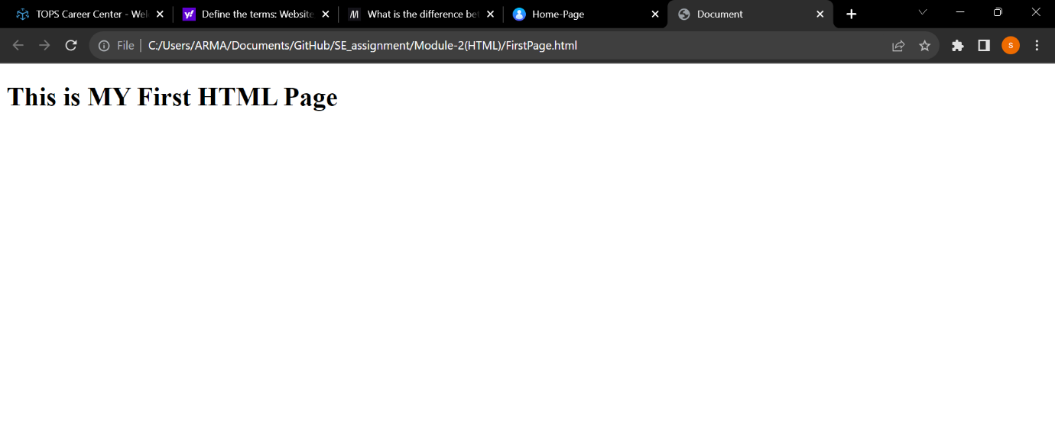

# Display top 10 IT companies list in html webpage:

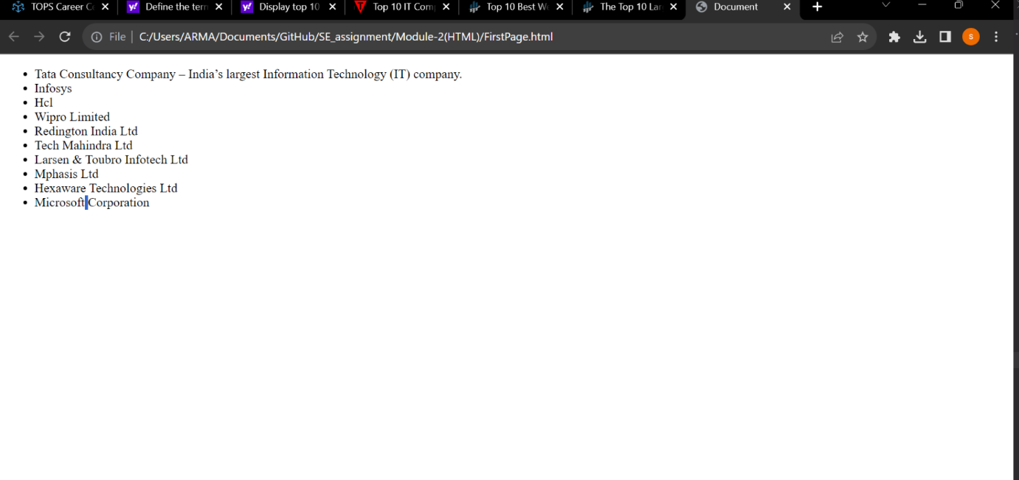

# Create a dropdown list

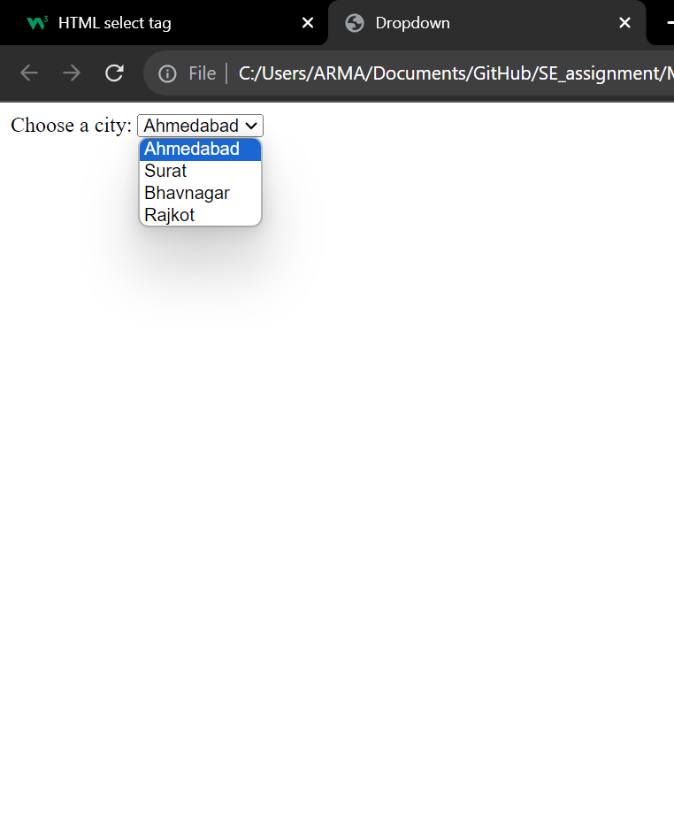

# Create a Table Of college Management system using row span & col span.

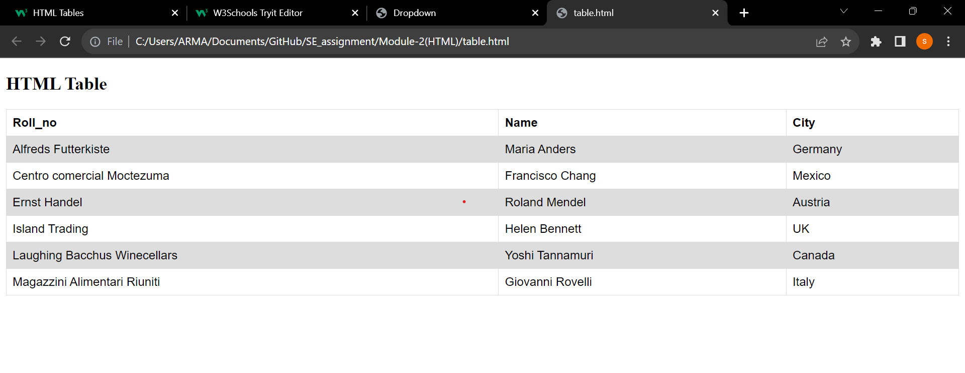

# Create Registration form using HTML, CSS:

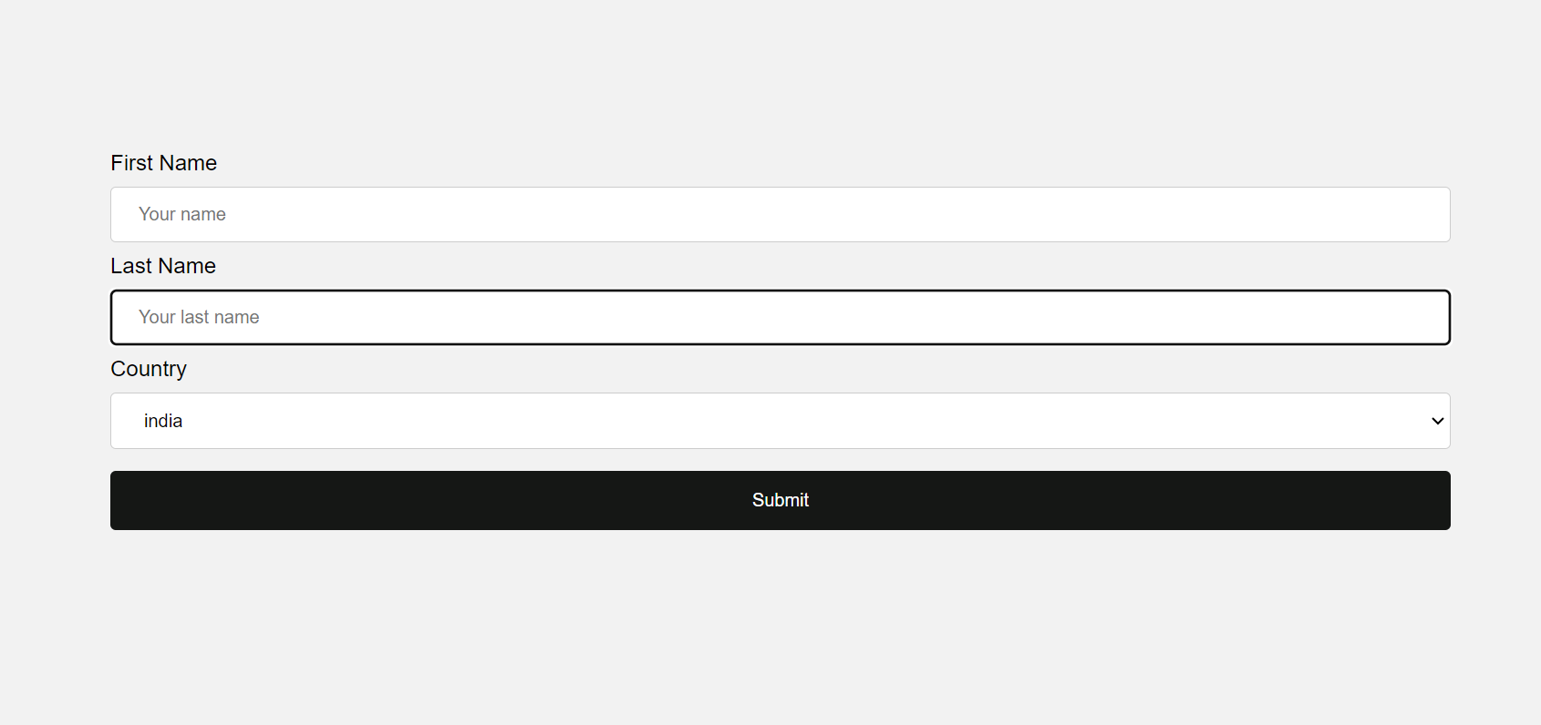

# In how many ways can a CSS be integrated as a web page?

# CSS can be added to HTML documents in 3 ways:

# Inline - by using the style attribute inside HTML elements

# Internal - by using a <style> element in the <head> section

# External - by using a <link> element to link to an external CSS file

# The most common way to add CSS, is to keep the styles in external CSS files. However, in this tutorial we will use inline and internal styles, because this is easier to demonstrate, and easier for you to try it yourself.